1. (a) Figures 1.1 and 1.2 show two constant current generators. Explain the operation of the circuit of Figure 1.1 and state what the key differences between it and the circuit in Figure 1.2. Show equations where necessary.
[6]

(b) Calculate the fractional temperature coefficient for the constant current generators shown Figure 1.1 and 1.2 at room temperature, given that R is a polysilicon resistor with a temperature coefficient of 1500 ppm/°C, the temperature coefficient of V_{BE} to be
-2.5mV/°C both at T=300K. State all assumptions.
[6]

(c) Voltage and current-sources are key components in analogue circuit design. Sketch a typical band-gap voltage reference circuit and prove that the temperature coefficient of the output voltage V₀ is zero if V₀ = 1.283 V. Assume the temperature coefficient of V_{BE} to be -2.5mV/°C, Boltzmann’s constant k = 1.38 x 10⁻²³ J/K and electron charge q = 1.6 x 10⁻¹⁹ C.
[8]

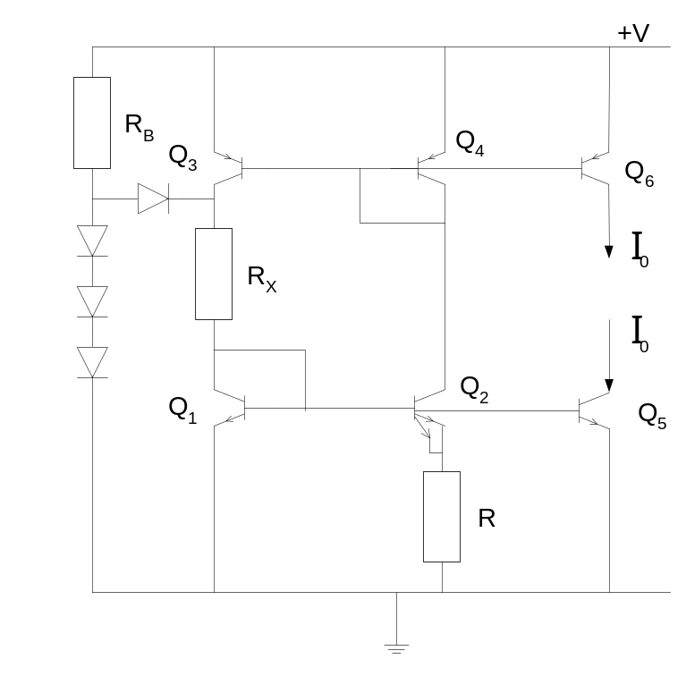

Figure 1.1
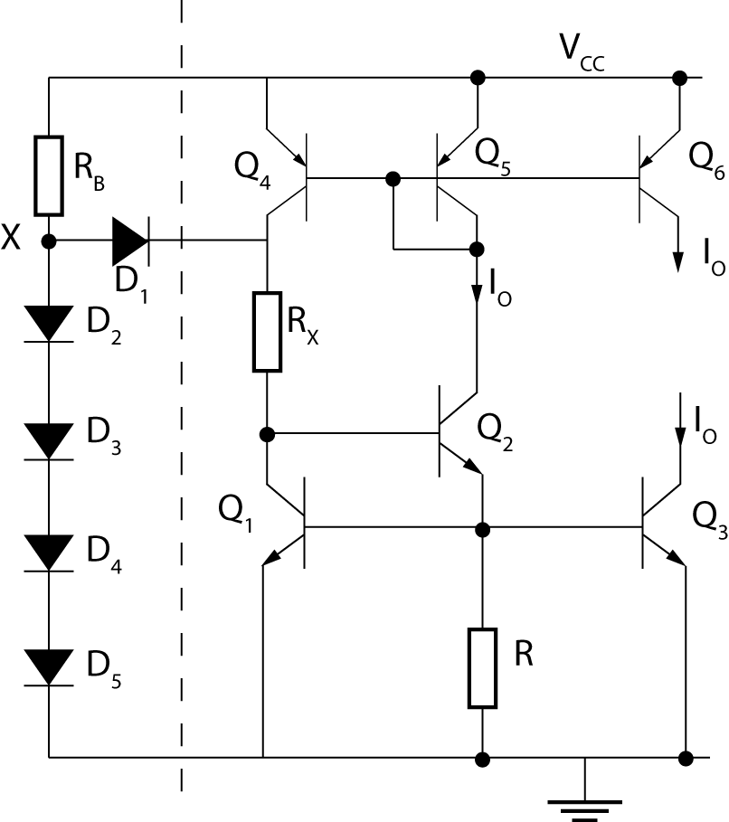
Figure 1.2

2. (a) Figure 2.1 shows a folded cascode connection. What is the main advantage of this design
over the more classical cascode connection? Show via a brief sketch how the architecture
of Figure 2.1 can be used to form the basis of a single stage fully differential folded
cascode operational amplifier (op-amp) with common-mode feedback included.
[6]

- Figure 2.2 shows a two-stage CMOS op-amp. Estimate the low-frequency differential voltage gain and the gain-bandwidth product of the amplifier. The aspect ratios of all devices are shown on the circuit. Assume that all bulk effects are negligible. The device model parameters are given below. What is the main advantage and disadvantage of a single-stage compared to a two-stage op-amp ?
[10]

- Explain why a resistor in series with the compensation capacitor C in Figure 2.2 can significantly improve the amplifier’s phase margin.
[4]

CMOS transistor parameters

Model parameters Kp (μA/V²) λ (V ⁻¹) V_{T0} (V)

PMOS 20 0.03 -0.8
NMOS 30 0.02 -1.0

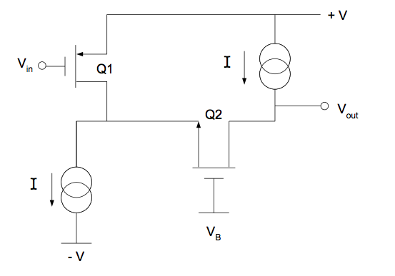

Figure 2.1

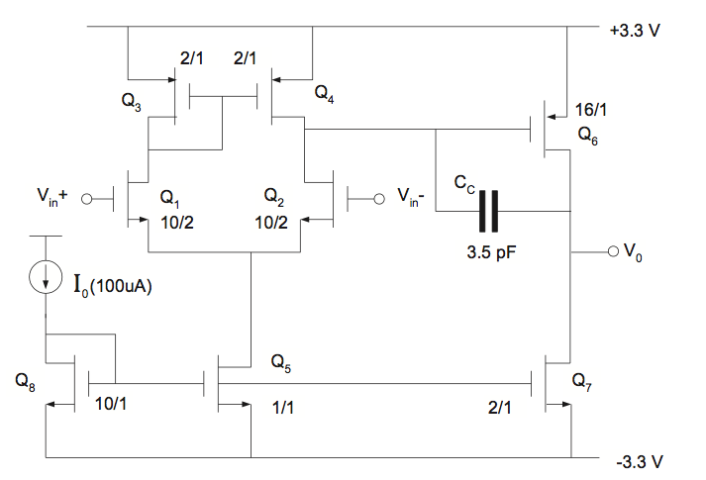

Figure 2.2

3. (a) (i) Explain the principles of sigma delta modulation.
[5]
(ii) Sketch a typical circuit architecture of a sigma delta modulator.

[5]

(b) Figure 3 shows one bit of an algorithmic data converter.

(i) Explain how the data conversion works.
[3]
(ii)Show how this can be cascaded to perform an 8-bit data conversion.

[4]
(c) What noise limits the resolution of sampled-data converters?

[3]
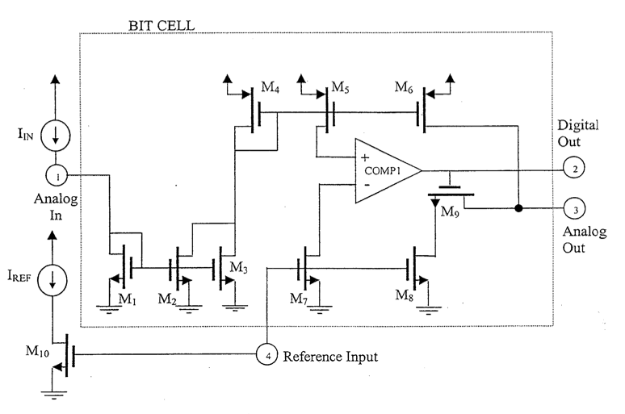

Figure 3.

4. (a) Under what operating conditions does the MOSFET of Figure 4.1 realise a linear floating
resistor between terminals A and B ? Explain why the bulk is not connected to the
source.
[6]

(b) Discuss three sources of non-linearity in the single MOSFET resistor realisation of Figure 4.1 and suggest one suitable circuit design to help eliminate one or more of these non-linear terms. Show all necessary circuit analysis to confirm your design.
[6]

(c) Figure 4.2 shows a fully differential continuous time integrator using a balanced double differential linear active transresistor. Derive an expression for the time constant of the integrator. You may ignore all bulk effects, and assume all MOSFETs are operating in the triode region.
[8]

G
S
D
V_{bulk}
A
B
A
B
R_{AB}

Figure 4.1

.

V_{SS}
V_{SS}
+
-
+
-
Vo
C₁
C₁
V_{C2}
V_{C1}
V_{C1}
I₁
I₂
-V_{IN}
I_{D4}
I_{D3}
V_{IN}
I_{D1}
I_{D2}

Figure 4.2

5. (a) Sketch a suitable circuit for a regulated cascode current-mirror and explain why the output resistance is larger than the output resistance of a traditional cascode.
[6]
(b) For the current mirror of Figure 5.1 derive the voltage swing in terms of device threshold voltage V_{T}, clearly stating any assumptions you make.
[6]

(c) Sketch a suitable two transistor and four transistor potential divider voltage reference circuit and show that when VDD=+5V, VSS=-5V and ID=10uA, for an output voltage Vout=0, the four transistor circuit consumes less area than the two transistor one. You may assume K_{P}=8μA/V², K_{N}=17μA/V², V_{TN}=V_{TP}=1V.
[8]

Q₁
(W)
Q₃
(W/4)
Q₆
(W)
Q₅
(W)
Q₄
(W)
Q₂
(W)
I_{o}
I_{in}
V_{DD}

Figure 5.1

6. Figure 6 shows the basic design of an analogue sampled-data precision integrator.

(a) Derive an expression for the transfer function of the integrator. Assume that the integrator is driven by non-overlapping clocks and that the switches are ideal.
[10]

(b) (i) Sketch the basic design of a 3rd-order Chebyshev low pass switched-capacitor ladder filter.

The filter is to have a cut-off frequency of 5kHz. Assume a clocking frequency of 100 kHz. The values of integration capacity for the capacitor based sections are 5.08pF and inductive section is 3.49pF. All other switched capacitors are 1pF.
[5]

- From the circuit, estimate normalised passive component values for the original double-terminated LC prototype of the filter. All values should be normalised to 1 rad/s. You may assume that the clocking frequency is so high that the integrators can be assumed lossless.

[5]

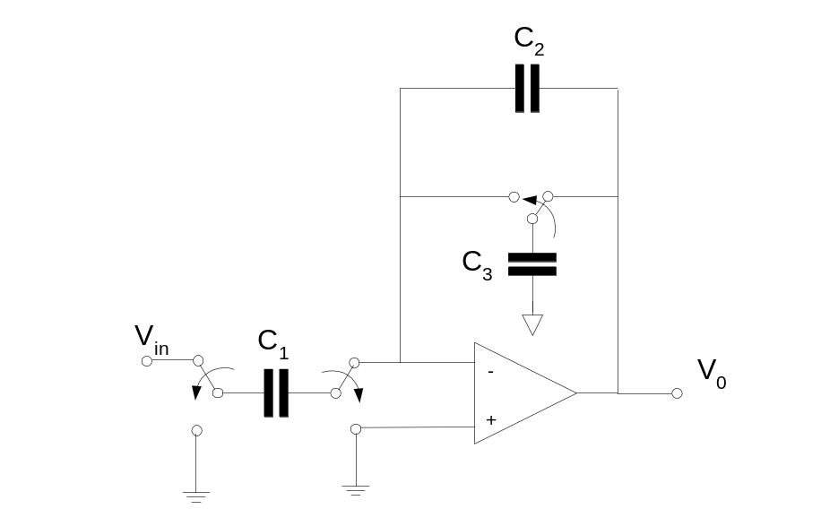

Figure 6.

